REQUEST FOR QUOTATION

Date: 16th.January.2023

From:
Norwegian Refugee Council (NRC) - Sudan
Khartoum Country Office

Address: Africa Street, Nile Tower, 4th Floor, St. 63
15.560261551708368, 32.552712818691106

Contact Person: | Aseel Alnaw
Position: | Logistics Assistant - Procurement
Email: | aseel.alnaw@nrc.no - sd.procurement@nrc.no
Phone: | 0911736126 - 0128347543

Deadline for submission: 19th of January 2023 @ 4:00 PM (GMT +2)

1 - NRC is looking for supplier to provide the following items:

No | Items | Specifications | Unit | Qty | Unit Price with VAT | Total Price with VAT
1 | Steel Cabinet | 2 doors, lockable, size 100x40xh190 | Piece | 11
GRAND TOTAL (incl. VAT)

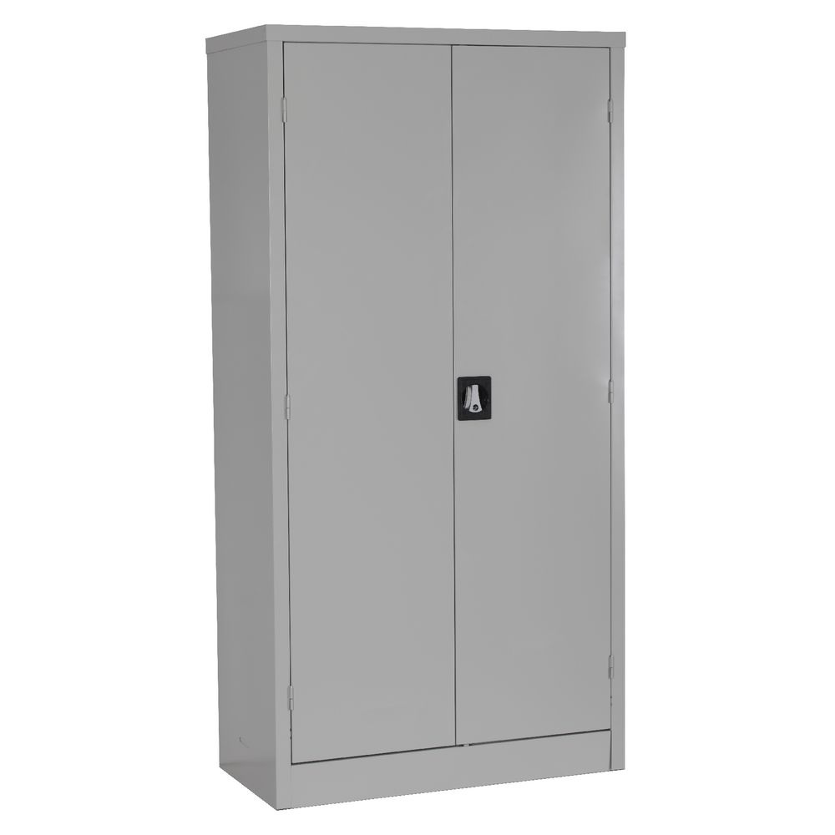

In any case, be sure to include VAT (in prices or in total).
If different taxes & fees apply, please specify them all in your quotation

2 - Please answer the questions:

Questions | Answers
What is the currency of the offer?
(SDG, USD, other…)

Note that NRC will favour quotes in USD. Please read below regarding USD payments.

DO NOT PROVIDE QUOTES IN BOTH SDG AND USD CURRENCIES.

Please confirm your prices include all taxes and fees (net prices):
(if not, please explain and detail the taxes & fees)

If your offer is in USD => payment will be made by bank transfer.
- Do you have a USD account in Sudan? If YES, then in which bank.
- Do you have a USD account abroad? If YES, then in which bank.
(please provide bank details for each account)

Please read the note below regarding payments in USD and quote accordingly.

Do you accept payment after delivery?
(Within 30 days).
(if not, please explain your payment terms)

What is the validity period of your offer?
(in days)

Please confirm you can deliver to our address in:

Sudan Country Office – 4th Floor, Nile T
ower, Fourth Floor, Block 10, Building #
20, Street 63, Khartoum
Sudan
Please confirm providing technical specifications (Photos) for each item (Mandatory)
Failure in providing samples will lead for disqualification for further assessment
What is the delivery time?
(please specify delivery schedule if any)
Is delivery included in the price?
(if not, please add a line for the delivery cost)

3 - Accepted methods for submission of quotation / offer:

We recommend you to fill up this Request for Quotation directly on your computer.

You can also print it and fill it up by hand if you have not access to a computer.

You can submit the price offer by using the table on page 1, or by using your own pro-forma document.

RFQ Hand delivery to:
Address: Africa Street, Nile Tower, 4th Floor, St. 63
15.560261551708368, 32.552712818691106
Or email to sd.procurement@nrc.no and Cc: aseel.alnaw@nrc.no

Your quotation / offer must be signed and stamped on all pages (including the present Request for Quotation).

NRC will evaluate and contract one supplier for the three lots, OR NRC will contract supplier for each lot as necessary and depending of evaluation results.
IMPORTANT NOTE regarding USD quotes and payments:

- You must choose between quoting in USD or quoting in SDG.
  - Do not provide quotes in both currencies. If you do so, only your quote in USD will be considered for assessment.
- If your quote is in USD, then you will be paid in USD.
  - You must be in capacity to accept the payment.
- NRC will favour payment in USD, in Sudan, in the same bank.
- NRC can also provide payment from our Head Office account to supplier’s account outside of Sudan. Be aware that this process can fail!
- NRC has USD bank accounts in :
  - Blue Nile Mashreg Bank
  - United Capital Bank.
- For payment within Sudan, you must have a bank account in one of the same bank as NRC.
- For payment outside of Sudan (UAE or others) to one of your company, please provide us with the following :
  - A quote under the name of your company abroad.
  - The bank account details of the company.

We encourage you to contact us directly if you have questions or need clarifications before submitting your quotation.

4 - Your Company details:

Name of the company

Name of the owner(s)
Date of birth of the owner(s)
(mandatory for screening)
Address of the company

Name of contact person

Position

Email

Phone

5 - Mandatory documents to attach to your quotation / offer:

Please check that you are providing all of the below mentioned documents:
Mandatory documents | Checked (Y/N)
Company registration certificate
Company tax registration certificate
Samples of all items mentioned in the above lots (1,2,3)
NRC Request for Quotation (filled up, signed and stamped)
Additional quotation on company letter head document, if any…

You can also attach additional documents such as photos, company profile, certifications…

6 - Payment information:

For payment by cheque, please indicate under which name NRC shall issue the cheque. You can write name in Arabic or in English.

Attention: if the name is not the company name, please provide a supporting letter to authorized NRC to issue the cheque under the name of the owner of the company or under the name of one of its employee. Contact us directly for more details.

For payment by bank transfer, please provide us with bank account information.

7 - Other information:

Payment will be made by bank transfer/cheque only.

All suppliers doing business with NRC should maintain high standards on ethical issues, respect and apply basic human and social rights, ensure non-exploitation of child labour, and give fair working conditions to their staff. NRC reserves the right to reject quotations provided by suppliers not meeting these standards.

Vendors doing business with NRC will be screened on anti-corruption due diligence before NRC confirms an order or contract.

NRC aims to purchase products and services that the minimum environmental impact. Environmental considerations form part of the NRC selection criteria, and NRC reserves the right to reject quotations provided by suppliers not meeting these standards.

NRC is obliged to ensure that its procurement decisions are clearly justified and documented and keeping within the Donors mandatory principles. In that regard, full and on-the-spot access must be granted to representatives of NRC, the Donor or any organisation or person mandated by it, to premises belonging to NRC or its contractors. The right to access shall include all documents and information necessary to assess, or audit the implementation of the contract

NRC reserves the right to accept or reject the whole or part of your quotation based on the information provided. Incomplete quotations which do not comply with our conditions will not be considered.

Shortlisted suppliers may be required to submit samples of each item. Please be sure to have all samples available at short notice, and wait for a response from NRC if you have been shortlisted.

